Thallus Organization in Fungi
The thallus is the vegetative body of a fungus. Unlike higher plants, fungi do not have true roots, stems or leaves. The fungal thallus may be unicellular or multicellular, depending on the group.

1. Unicellular Thallus
Some fungi have a single-celled body that performs all vegetative functions.
- The most common example is yeast (Saccharomyces).
- Cells are generally oval or spherical.
- Reproduction commonly occurs by budding or, in some fungi, by fission.
- Under certain conditions, some yeasts can form chains of elongated cells called pseudohyphae.

2. Filamentous Thallus
Most fungi possess a multicellular, filamentous thallus consisting of numerous thread-like structures called hyphae.
Hypha: A tubular filament that represents the basic structural unit of a filamentous fungus.
Mycelium: A network or mass of interconnected hyphae forming the main vegetative body of the fungus.
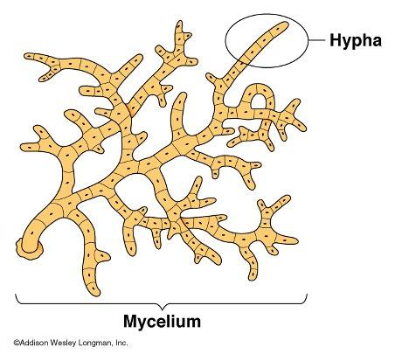
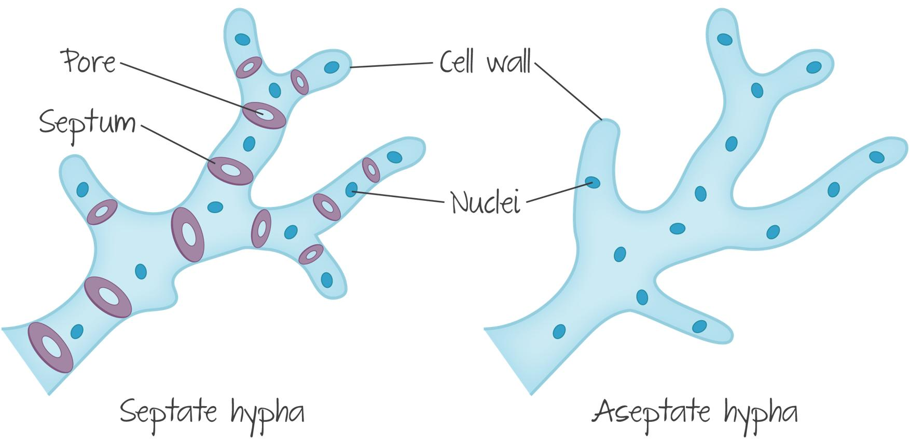
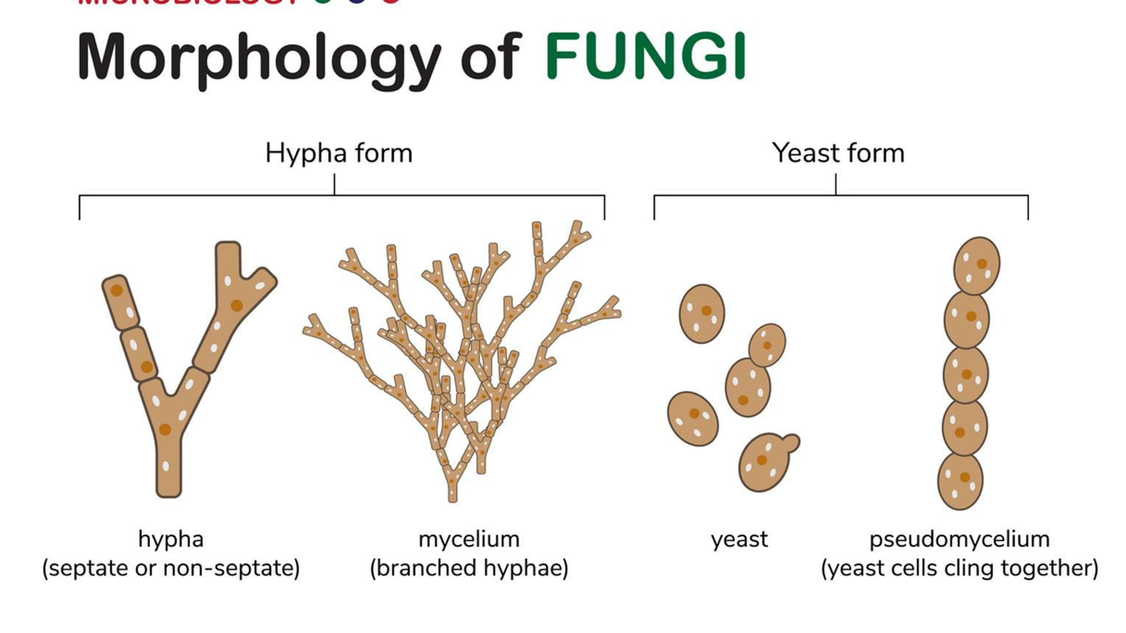
5

3. Septate Hyphae
In septate hyphae, the filament is divided by cross-walls called septa into individual compartments.
- Septa usually contain pores that allow movement of cytoplasm and organelles between compartments.
- They are characteristic of many higher fungi, particularly Ascomycota and Basidiomycota.
- Example: Aspergillus, Penicillium and Agaricus.

4. Aseptate or Coenocytic Hyphae
Aseptate hyphae lack regular cross-walls and form a continuous multinucleate cytoplasmic mass.
- They are also called coenocytic hyphae.
- Septa may develop temporarily, particularly around reproductive structures or damaged regions.
- Commonly found in members traditionally grouped under Zygomycetes, such as Rhizopus.

5. Specialized Thallus Forms
Fungal hyphae can become organized into specialized structures for survival, reproduction and nutrient acquisition.
- Rhizoids: Root-like structures that help in attachment and absorption; common in Rhizopus.
- Stolons: Horizontal hyphae that connect different regions of the colony.
- Haustoria: Specialized absorbing structures that penetrate host cells and obtain nutrients in parasitic fungi.
- Sclerotia: Compact, hardened masses of hyphae that help the fungus survive unfavourable conditions.
- Rhizomorphs: Thick, root-like bundles of hyphae that facilitate growth and transport.

Fungal Tissue, Nutrition, Homothallism and Heterothallism

1. Fungal Tissue
Fungi generally do not possess true tissues like higher plants. However, in many multicellular fungi, hyphae become organized into tissue-like structures called plectenchyma. These structures are formed by the aggregation and interweaving of hyphae.

Types of Plectenchyma
a. Prosenchyma:
Hyphae remain more or less parallel and retain their individual filamentous appearance. The structure is relatively loose and resembles a bundle of hyphae.
b. Pseudoparenchyma:
Hyphae become closely packed and are transformed into short, rounded or polygonal cells. It resembles the parenchymatous tissue of plants.
Plectenchymatous tissues may form specialized structures such as stroma, sclerotia and fruiting bodies, which provide support, protection and sites for reproduction.

2. Nutrition in Fungi
Fungi are heterotrophic organisms because they lack chlorophyll and cannot synthesize their own food through photosynthesis. They obtain nutrients by secreting extracellular digestive enzymes into the surrounding substrate and absorbing the resulting soluble nutrients.

Major Modes of Nutrition
a. Saprophytic Nutrition
Saprophytic fungi obtain nutrients from dead and decaying organic matter. They play an important role in decomposition and nutrient recycling.
Examples: Rhizopus, Mucor and many mushroom-forming fungi.
b. Parasitic Nutrition
Parasitic fungi obtain nutrients from living hosts, often causing diseases in plants, animals or humans. Some form specialized structures called haustoria for nutrient absorption.
Examples: Puccinia (rust fungus), Albugo and Ustilago.
c. Symbiotic Nutrition
Fungi may live in mutually beneficial associations with other organisms.
- Mycorrhiza: Association between fungal hyphae and plant roots, where the fungus helps in water and mineral absorption while receiving organic nutrients from the plant.
- Lichens: Symbiotic association between a fungus and a photosynthetic partner, usually a green alga or cyanobacterium.

3. Homothallism
Homothallism refers to the condition in which a single fungal strain is self-fertile and can complete sexual reproduction without requiring a genetically different compatible strain.
The compatible sexual functions are therefore present within the same thallus or strain.
Example: Some species of Mucor and Aspergillus are homothallic.
Significance:
Homothallism allows sexual reproduction to occur even when only a single compatible strain is present.

4. Heterothallism
Heterothallism is the condition in which two genetically different but compatible strains are required for sexual reproduction.
The individual strains are usually designated as + and − mating types rather than male and female.
For example:
Strain (+) + Strain (−) → Sexual reproduction
Example: Neurospora crassa is a well-known heterothallic fungus.
Significance:
Heterothallism promotes genetic recombination and variation by requiring interaction between compatible strains.

