Structure of Dicot and Monocot Root, Stem and Leaf
The internal structure of roots, stems and leaves differs between dicotyledonous and monocotyledonous plants. These differences are mainly related to the arrangement of vascular tissues, presence or absence of cambium, secondary growth and organization of ground tissue.

1. Root Structure

A. Dicot Root
A typical dicot root, such as bean, shows the following tissues from outside to inside:
- Epiblema (rhizodermis): The outermost single layer of thin-walled cells. It bears root hairs for absorption of water and minerals.
- Cortex: Several layers of parenchymatous cells with intercellular spaces. It mainly stores food and facilitates movement of water towards the vascular cylinder.
- Endodermis: The innermost layer of the cortex. Its cells possess Casparian strips, which regulate the movement of water and dissolved substances into the stele.
- Pericycle: A single layer of cells immediately inside the endodermis. It gives rise to lateral roots and contributes to vascular cambium and cork cambium during secondary growth.
- Vascular tissue: Xylem is usually star-shaped and exarch, with a relatively small number of xylem arms (commonly 2–6). Phloem occurs between the arms of xylem.
- Pith: Very small or inconspicuous and often largely occupied by vascular tissue.
Important feature: Dicot roots generally possess open vascular bundles and undergo secondary growth due to the development of vascular cambium.
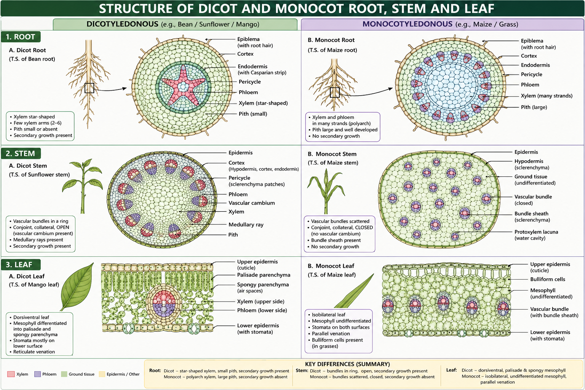

B. Monocot Root
A typical monocot root, such as maize, has:
- Epiblema: Single-layered outer tissue with numerous root hairs.
- Cortex: Broad region consisting of several layers of parenchymatous cells.
- Endodermis: Distinct single layer surrounding the stele.
- Pericycle: Single-layered and located inside the endodermis.
- Vascular tissue: Xylem and phloem occur in many alternating strands (polyarch condition). Xylem is exarch.
- Pith: Large, well-developed and parenchymatous.
- Secondary growth: Generally absent because a normal vascular cambium does not develop.

2. Stem Structure

A. Dicot Stem
A typical dicot stem, such as sunflower, contains:
- Epidermis: Outermost protective layer, often covered by a cuticle.
- Cortex: Differentiated into hypodermis, general cortex and endodermis. The hypodermis is commonly collenchymatous.
- Pericycle: Often represented by patches or a continuous zone of sclerenchymatous tissue outside the vascular bundles.
- Vascular bundles: Arranged in a ring. Each bundle is conjoint, collateral and open, because vascular cambium is present between xylem and phloem.
- Medullary rays: Parenchymatous rays occur between vascular bundles and facilitate radial transport.
- Pith: Large and parenchymatous, occupying the central region.
The presence of vascular cambium allows secondary growth, resulting in an increase in stem thickness.

B. Monocot Stem
A typical monocot stem, such as maize, shows:
- Epidermis: Single-layered and covered by a cuticle.
- Hypodermis: Generally composed of sclerenchymatous cells, providing mechanical support.
- Ground tissue: Not clearly differentiated into cortex, endodermis, pericycle and pith. It forms a relatively uniform ground tissue.
- Vascular bundles: Numerous and scattered throughout the ground tissue. They are generally smaller towards the periphery and larger towards the centre.
- Vascular bundles: Conjoint, collateral and closed, lacking vascular cambium.
- Bundle sheath: Each vascular bundle is surrounded by a prominent sclerenchymatous bundle sheath.
- Protoxylem lacuna: A water-containing cavity formed by the disintegration of protoxylem is commonly present.
Secondary growth is generally absent in typical monocot stems.

3. Leaf Structure

A. Dicot Leaf
A typical dicot leaf, such as mango or sunflower, is generally dorsiventral, with distinct upper and lower surfaces.

Internal structure
- Upper epidermis: Usually single-layered and covered with a cuticle. Stomata are generally fewer on the upper surface.
- Mesophyll: Differentiated into:
  - Palisade parenchyma: Located below the upper epidermis; cells are elongated and densely packed with chloroplasts and are specialized for photosynthesis.
  - Spongy parenchyma: Located below the palisade tissue; cells are loosely arranged with large intercellular spaces that facilitate gaseous exchange.
- Vascular bundles: Present within the veins and veinlets. They are generally collateral and closed, with xylem towards the upper/adaxial side and phloem towards the lower/abaxial side.
- Lower epidermis: Usually contains a greater number of stomata than the upper epidermis.
Thus, the mesophyll is clearly differentiated into palisade and spongy tissues.

B. Monocot Leaf
A typical monocot leaf, such as maize, is generally isobilateral, with similar upper and lower surfaces.

Internal structure
- Epidermis: Both upper and lower epidermises are usually single-layered and covered with a cuticle.
- Stomata: Usually present on both surfaces.
- Bulliform cells: Large, thin-walled cells occur in groups in the upper epidermis of many grasses. They help in leaf rolling during water stress.
- Mesophyll: Usually not differentiated into distinct palisade and spongy regions.
- Vascular bundles: Numerous and arranged in parallel rows, reflecting parallel venation. Larger bundles are often surrounded by prominent bundle sheaths.
- Bundle sheath: Well developed around vascular bundles and may participate in photosynthetic functions in C₄ grasses such as maize.

