Root and Shoot Apical Meristems
Apical meristems are regions of actively dividing, undifferentiated cells located at the growing tips of roots and shoots. They are responsible for primary growth, which increases the length of the plant body. The two major types are the shoot apical meristem (SAM) and root apical meristem (RAM).

1. Shoot Apical Meristem (SAM)
The shoot apical meristem is located at the tip of the stem and gives rise to the primary shoot system, including the stem, leaves, axillary buds and reproductive structures. Its cells are small, actively dividing, have dense cytoplasm, prominent nuclei and relatively small vacuoles.
The SAM is organized into distinct regions. In many angiosperms, the central zone contains slowly dividing stem cells, while the surrounding peripheral zone contains cells that divide more actively and contribute to the formation of leaf primordia and other lateral organs. A rib zone below the central region contributes mainly to the internal tissues of the stem. The SAM maintains a population of stem cells through a balance between cell division, differentiation and self-renewal.

Major functions of SAM
- Produces new cells for stem elongation.
- Initiates leaf primordia and lateral organs.
- Produces axillary meristems.
- Maintains the shoot stem-cell population.
- Contributes to the formation of flowers and reproductive shoots during the reproductive phase.
- 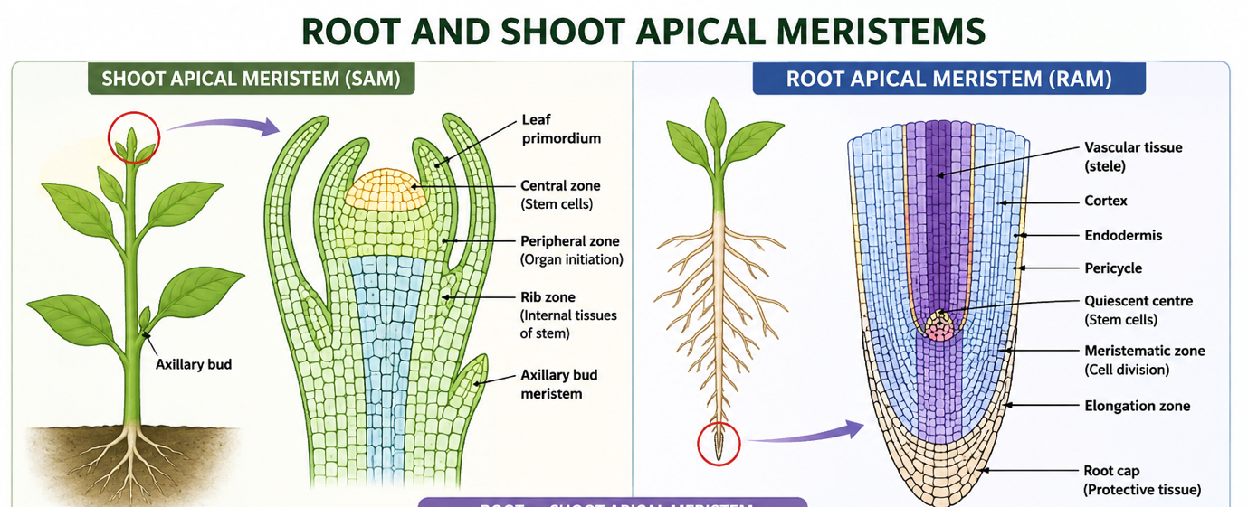

2. Root Apical Meristem (RAM)
The root apical meristem is located near the tip of the root and produces the tissues responsible for primary root growth. Unlike the SAM, the RAM is protected by a root cap, which covers the root tip and protects the delicate meristematic cells as the root penetrates the soil.
The RAM contains a population of relatively slowly dividing cells called the quiescent centre (QC). Surrounding stem/progenitor cells divide and produce the different tissues of the root. Cells derived from the RAM differentiate into the epidermis, cortex, endodermis, pericycle and vascular tissues.

Major functions of RAM
- Promotes elongation of the root.
- Produces the different primary root tissues.
- Maintains root stem cells.
- Contributes to the formation of lateral roots through the pericycle.
- Works with the root cap to facilitate growth through soil.

