FLUORESCENCE MICROSCOPE
Certain chemical compounds absorb light and reemit part of the radiant energy as light of longer wavelength. Such substances are called fluorescent and the phenomenon is termed as fluorescence. In fluorescence microscopy, a high intensity mercury lamp is used as the light source, which emits white light. The exciter filter transmits only blue light to the specimen and blocks out all the colours. The blue light is reflected downward to the specimen by the dichroic mirror (a special type of mirror that separates light based on its wavelength, reflecting some colors while allowing others to pass through). The specimen is stained with fluorescent dye (acrydine orange). Only certain portions of the specimen retain the dye, others do not. The stained portion of the specimen absorb blue light and emit green light, which passes upwards, penetrate the dichroic mirror and reaches the barrier filter. This filter allows only green light to pass through and the eye receives only green light emitted from the specimen against the black background whereas unstained portions are invisible. Also, ultraviolet light is used to excite molecules so that they release light of a different wavelength.
This technique is especially important in immunology in which the reactions of antigens and antibodies are studied in great detail. Fluorescent antibody staining is now widely used in diagnostic procedures to determine whether an antigen is present. Not all bacteria get stained with fluorescent chemicals. Excitation and fluorescence with chromatic beam splitters is here. Similar to the interference filters these are specially coated mirrors used under 45° to the illuminating beam. They reflect certain spectral ranges, while others are completely transmitted. The separating line between reflection and transmission may be set at any point of the spectrum. 1. Exciting radiation, 2. Fluorescence emission.
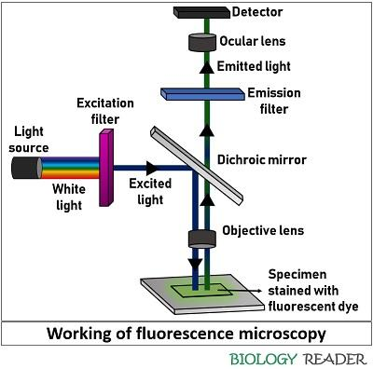
Application:
- Rapid diagnosis of different fungi, such as yeast, Microsporum, Trichophyton, etc., especially in immune compromised patients
- Determining the location of an antigen or antibody in a tissue section or smear by the pattern of fluorescence, using specific antibody or antigen labeled with a fluorochrome.
- Diagnosis of invasive carcinomas, which present as bright masses with irregular borders composed of fluorescent neoplastic nuclei with surrounding hypofluorescent fibroadipose tissue.
- Effective for analysis of interphase nuclei, transcription, genes, chromosomal translocation and small chromosomal aberrations; aids in the diagnosis of multiple myeloma and leukemia
- Analysis of intracellular distribution of the nucleus, cell membranes and various intracellular structures, such as cytoskeletal filaments, mitochondria, golgi apparatus
- Studying living cells and measuring pH, free calcium and NAD(P)H concentration in the cytoplasm
- Visualizing DNA and RNA sequences in molecular cytogenetics by using fluorescent probes, which bind to segments of nucleic acid showing high degree of sequence complementarity.

Confocal Laser Scanning Microscope (CLSM):
Light sources used in confocal microscopes are lasers. A confocal microscope is an optical imaging technique that uses a pinhole to block out-of-focus light, allowing for high-resolution, three-dimensional visualization of thick specimens by creating optical sections. It works by scanning a focused laser beam across a sample and detecting the fluorescence from a single focal plane after it passes through a pinhole, which rejects stray light and improves image contrast and resolution. This allows for sharp, clear images of living and fixed cells and is used in fields like cell biology, neuroscience, and cancer research.
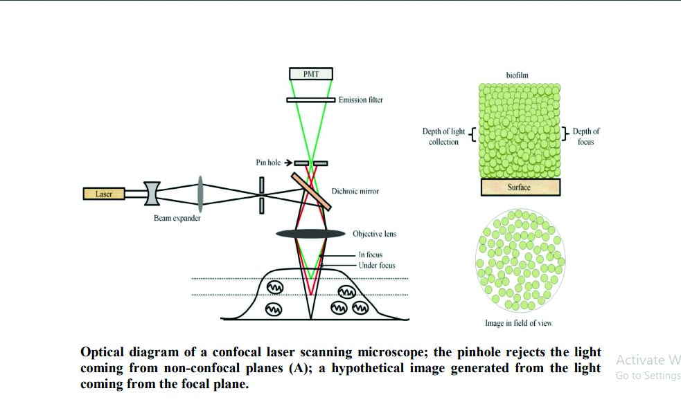
Point illumination: A laser scans a small point on the specimen, causing the fluorophores at that point to fluoresce.
Pinhole filtering: The emitted fluorescence passes back through the objective lens and is directed toward a detector. Before reaching the detector, it passes through a pinhole.
Out-of-focus light rejection: The pinhole is positioned so that only light from the in-focus point can pass through it. Light from above or below the focal plane is blocked by the pinhole, which prevents it from reaching the detector.
Image construction: The laser scans the entire specimen point-by-point, and the intensity of the light from each point is used to build up a high-resolution 2D image. By scanning at different depths, a series of 2D optical sections can be collected to create a 3D reconstruction of the sample.

Applications and Advantages:
- 3D imaging : Creates sharp 3D images of biological samples, including living cells.
- Improved contrast and resolution: The pinhole design greatly reduces background haze, resulting in images with high contrast and clarity compared to conventional microscopes.
- Thick specimen analysis: Allows for the analysis of thick specimens without the need for physical sectioning.
- Live cell imaging: Enables the examination of living specimens with enhanced clarity.

Limitations:
- Limited depth: Light penetration is limited, so imaging very thick samples can be challenging and difficult.
- Phototoxicity and photobleaching: The high-intensity laser can damage living cells or cause fluorescent dyes to fade (photobleach), especially during long imaging sessions.
- Expensive: Confocal microscopes are significantly more expensive than conventional microscopes.

Applications of Confocal Microscopy:
Confocal microscopy is a valuable tool across many scientific fields, including:-
Cell biology: Visualizing the location of proteins and other molecules within cells, analyzing cell formation, and observing organelles.
Developmental biology: Tracking the development and movement of cells in live organisms like zebrafish embryos.
Neuroscience: Mapping neural networks and observing calcium activity.
Materials science: Characterizing the surface and microstructure of materials.
Ophthalmology: Diagnosing diseases and infections of the cornea.
Pharmaceuticals: Ensuring quality and uniformity in thin-film drugs

